- First week of November 2021 - Memory Lane
Sunday | monday | tuesday | wednesday | Thursday | friday | Saturday
Oct 31  Happy Halloween  10:00am  Worship Service (TV channel 64)  10:45 What if  6:30pm  Relaxation (TV channel 64)  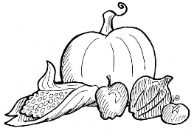 | 2  9:00am Manicures  11:30am  Reminisce  6:30pm  Relaxation (TV channel 64) | 3  9:00 Flex & Stretch  11:30am Short Story  1:00 On the Go Happy Hour  6:30pm  Relaxation (TV channel 64) | 4  10:00am All Saints Remembrance Service (TV channel 64)  11:30am Beach ball toss  5:00pm Horse Racing  6:30pm  Relaxation (TV channel 64) | 5 Theme Thursday-wear your hunting clothing  10:00 Hymn Sing (TV channel 64)  11:30am  Flex & Stretch  2:00 Mass (TV channel 64)  4:30pm  Bingo  6:30pm  Relaxation (TV channel 64) | 6  11:30 Parachute  5:00 Chicken Soup for the Soul  6:30pm  Relaxation (TV 64) | 7  10:45am  Dice  6:30pm  Relaxation (TV 64)

