- First week of November 2021 – Canary Creek
Sunday | Monday | Tuesday | WEDNESDAY | Thursday | Friday | SATurday
Oct 31st  Happy Halloween  8:15am What if (game)  10:00am Worship (TV channel 64)  6:30pm Relaxation  (TV channel 64) 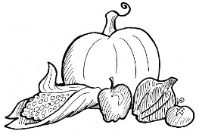 | 1  2:00pm Stretch & Flex  3:30pm Manicures  6:30pm  Relaxation (TV channel 64) | 2  10:30am Dice  1:00pn On the Go Happy Hour  6:30pm  Relaxation (TV channel 64) | 3  10:00am All Saints’ Remembrance Service (TV channel 64)  10:30am Stretch & Flex  2:30pm  Craft (Tissue Paper Poppies)  6:30pm  Relaxation (TV channel 64)  *Theme Thursday Hunting* | 4 Theme Thursday: Wear your hunting clothing  10:00am Hymn Sing (TV channel 64)  10:30am Trivia  2:00 Mass (TV channel 64)  2:30pm Bingo  6:30pm  Relaxation (TV channel 64) | 5  10:30am Flex & Stretch  2:30pm Grab & Talk  6:30pm  Relaxation (TV channel 64) | 6  8:15 Word Puzzles  11am  Exercise (TV channel 64)  6:30pm  Relaxation (TV channel 64)

