- First week of November 2021 - Mille Lacs Lake
Sunday | Monday | Tuesday | Wednesday | Thursday | Friday | Saturday
Oct 31  Happy Halloween  10:00am  Worship Service (TV channel 64)  11:00am Exercise (TV channel 64)  12:45 Word Puzzles  6:30pm  Relaxation (TV 64)  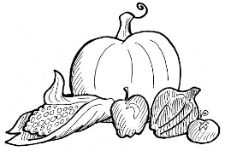 | 1  8:15 Reminiscing  1:00 Exercise (TV channel 64)  1:00 Manicures  6:30pm  Relaxation (TV channel 64) | 2  8:15am Would you rather  1:00pm On the go Happy Hour  6:30pm  Relaxation (TV channel 64) | 3  10:00am All Saints Remembrance Service (TV channel 64)  1:00pm  Craft (Tissue Paper Poppies)  6:30pm  Relaxation (TV channel 64) | 4 Theme Thursday-wear your hunting clothing  8:15 Current Events  10:00 Hymn Sing (TV channel 64)  12:30pm  1:00pm Horse Racing  2:00 Mass (TV channel 64)  6:30pm  Relaxation (TV 64) | 5  8:15am Trivia  1:00pm Bingo  6:30pm  Relaxation (TV 64) | 6  11am  Exercise (TV 64)  12:45 What if  6:30pm  Relaxation (TV 64)

