- First week of November 2021 – Sunny Lake
Sunday | Monday | Tuesday | Wednesday | Thursday | Friday | Saturday
Oct 31  Happy Halloween  10:00am Worship Service (TV channel 64)  11:00 Exercise (TV channel 64)  3:15 Word Puzzles  6:30pm  Relaxation (TV 64)  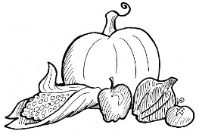 | 2  10:30 Flex & Stretch  1:00pm Exercise (TV channel 64)  3:00 Manicures  6:30pm  Relaxation (TV 64) | 3  10am Horse Racing  1:00pm On the Go Happy Hour  6:30pm  Relaxation (TV 64) | 4  10:00am All Saints Remembrance Service (TV channel 64)  3:00pm  Craft (Tissue Paper Poppies)  6:30pm  Relaxation (TV 64)  * | 5 Theme Thursday-wear your hunting clothing  10:00am Hymn Sing (TV channel 64)  10:30am Flex & Stretch  2:00pm Mass (TV channel 64)  3:00 Bingo  6:30pm  Relaxation (TV 64) | 6  1:00pm Exercise (TV channel 64)  3:15pm  Horseracing  6:30pm  Relaxation (TV 64) | 7  11am  Exercise (TV 64)  3:15pm What if  6:30pm  Relaxation (TV 64)

